Multiple choice section

|  |  |  |  |  |  |  |  |  |
| --- | --- | --- | --- | --- | --- | --- | --- | --- |
| Question | 1 | 2 | 3 | 4 | 5 | 6 | 7 | 8 |
| Answer | A | D | D | D | B | C | B | C |

Question 1 [10.4]

A

The object has not undergone a rotation, reflection or translation. Its shape and size has changed (dilation).

Question 2 [10.1]

**D**

Shifted or slid across the page.

Question 3 [10.2]

D

Reflected images maintain the same shape and size as the object, so they are not distorted. If the object is reflected about its axis of symmetry, the image will be identical to the object.

Question 4 [10.5]

D



Reflectional symmetry with two axes of symmetry and rotational symmetry.

Question 5 [10.5]

C

2 axes of symmetry

Question 6 [10.3]

**C**

The opposite of clockwise is anticlockwise.

360 – 72 = 288°

Question 7 [10.1]

**B**

Opposite of left is right; opposite of up is down.

5 units left – 5 units right

6 units up – 6 units down

Question 8 [10.4]

C

Reflections, rotations and translations are all types of transformations for which the image formed has the same dimensions (e.g. length and width) as the original object. The colour is unaffected by these transformations.

Multiple-choice total marks: 8

Short answer section

Question 9 4 marks [10.4]

A combined transformation involves two or more of the following: a translation, a rotation or a reflection. When combining transformations, the transformations are performed in sequence (i.e. one after the other).

An example of a combined transformation is when an object is translated 5 units downwards and is rotated by 50° in a clockwise direction.

Question 10 3 marks [10.1]

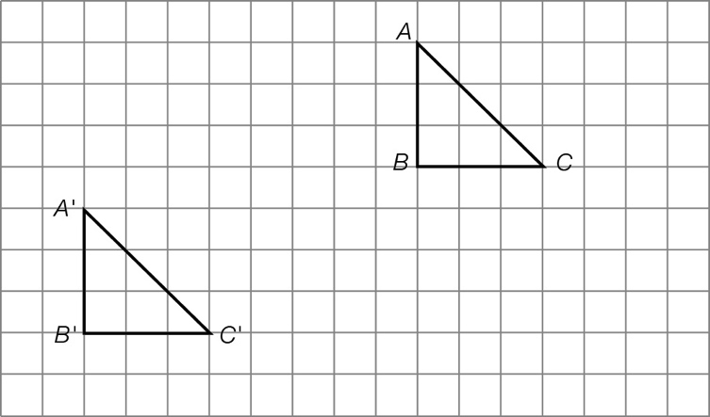

Question 11 6 marks [10.2]

(a)–(b)

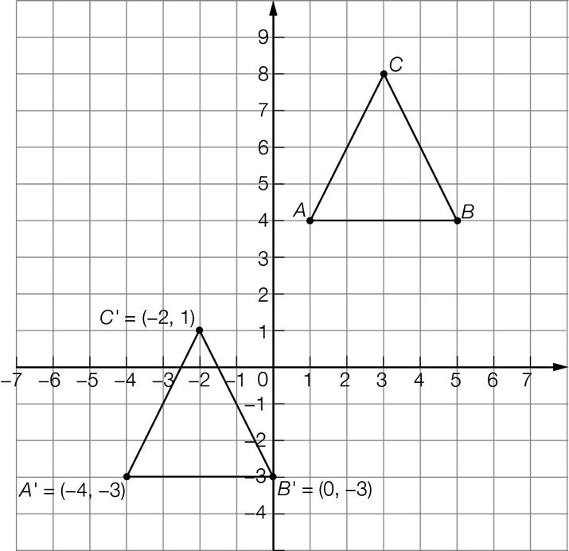

(c) Coordinates: A' (-4, -3) B' (0, -3) C' (-2, 1)

Question 12 2 marks [10.2]

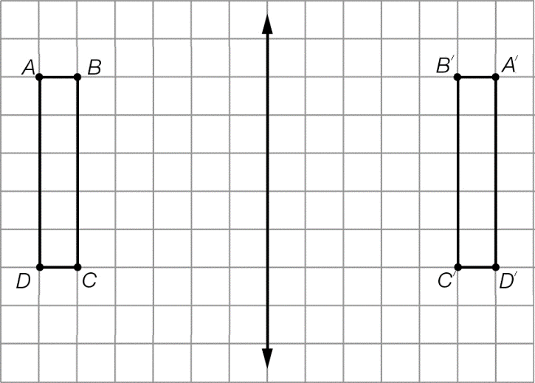

Question 13 2 marks [10.3]

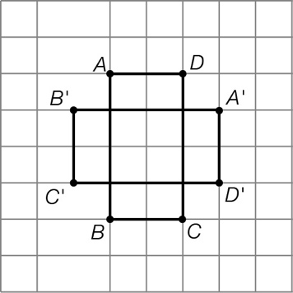

Question 14 2 marks [10.5]

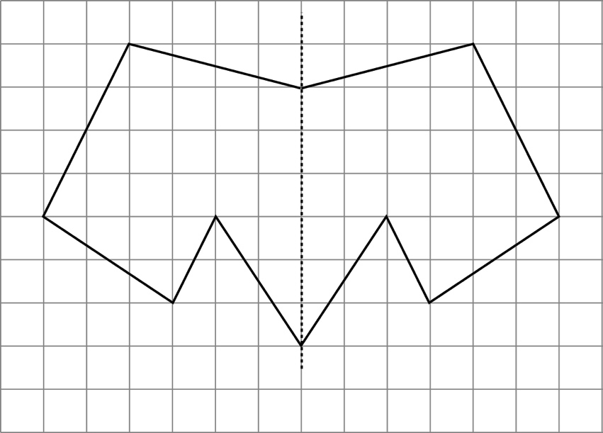

Question 15 3 marks [10.7]

|  |  |  |
| --- | --- | --- |
| (a) top view  Macintosh HD:Users:lizwaud:Desktop:PM7_eBook:Batch 1 commenced:Artwork_CORRECTED_041016_Use this:Ch10:PM2e_07_EB_10_ATS_01.jpg | (b) front view  Macintosh HD:Users:lizwaud:Desktop:PM7_eBook:Batch 1 commenced:Artwork_CORRECTED_041016_Use this:Ch10:PM2e_07_EB_10_ATS_02.jpg | (c) side view  PM7_SmB_SSa10_12a |

Question 16 3 marks [10.7]

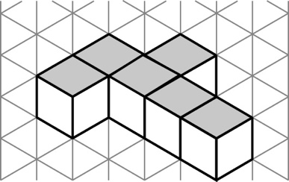

Question 17 4 marks [10.5]

(a) Sample answers: dodecahedron, 12-pointed star etc.

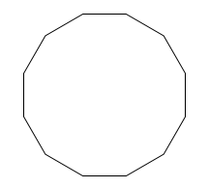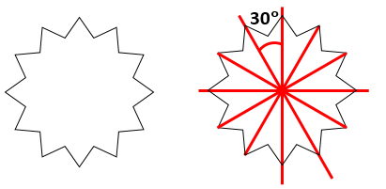

(b) 30° (360 divided by 12)



Question 18 4 marks [10.3]

The rotated image will be identical to the original shape in every way. It will be in the same position and its orientation will be the same.

This is because the object has been rotated 1080° and 1080 is a multiple of 360.

Question 19 4 marks [10.7]

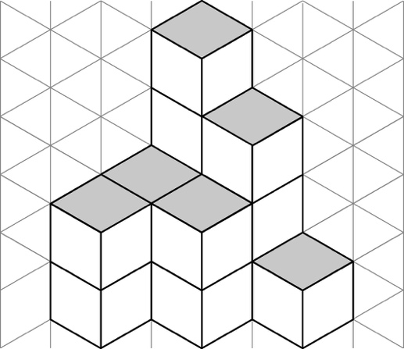

Short answer total: 37

Extended answer section

Question 20 4 marks [10.4]

(a) A'B'C'D' has been translated 4 units to the right and 2 units down

(b) A"B"C"D" has been rotated 45° anticlockwise about B'

Question 21 6 marks [10.2]

(a)–(c)

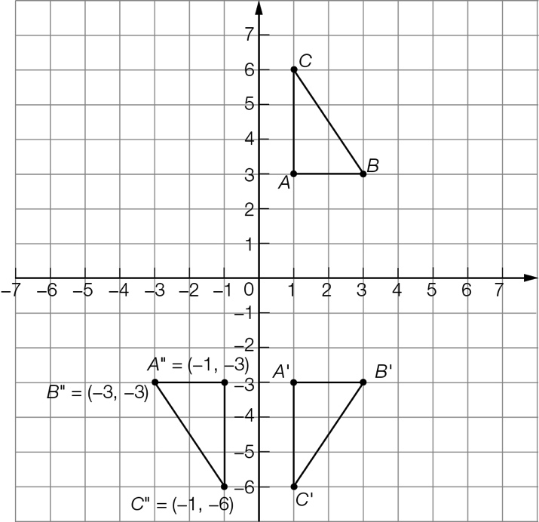

(d) coordinates A" (-1, -3) B" (-3, -3) C" (-1, -6)

Question 22 7 marks [10.5]

The number 1000001 was mentioned in the question.

The list of an additional seven numbers is:

1011101 1010101 1001001 1100011 1111111 1110111 1101011

Question 23 6 marks [10.3]

(a) The smallest angle would be = 6°

(b) The order of rotational symmetry would be 60.

(c) The regular polygon could be named a 60-gon.

Question 24 2 marks [10.2]

The actual time could be 11:05 am and the time seen in the reflection could be 12:55 pm.

Similarly, the actual time could be 11:05 pm and the time seen in the reflection could be 12:55 am. Furthermore, the actual time could be 5:35 pm and the time seen in the reflection could be 7:25 pm.

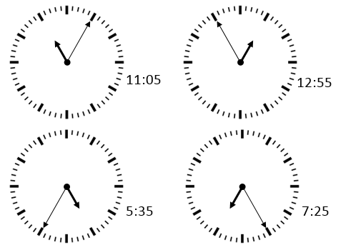

Question 25 4 marks [10.2]

(a) No.  
The angle i° formed from when light comes from Jerry’s shows hitting the mirror will always be bigger than the angle r° (light reflected from the mirror into Jerry’s eye). Consequently, Jerry will not be able to see his shoes no matter how far back he walks.   
This will be true as long as the mirror is perfectly flat (plane mirror) and perfectly vertical, and the ground Jerry walks on is perfectly horizontal.

(b) The surface of the mirror acts as the axis of reflection. The reflected image of Jerry’s knee will be 2 m behind the axis of reflection (mirror). The reflected image of Jerry’s knee will be the same distance from the ground as Jerry’s actual knee.

Extended answer total: 29

TOTAL test marks: 74